Indefinite Integral
Hossein Rahimzadeh
www.cafeplanck.com
info@cafeplanck.com

Type1
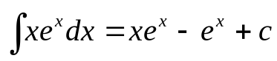
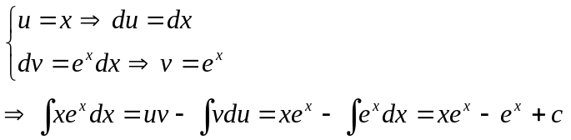

Type 2
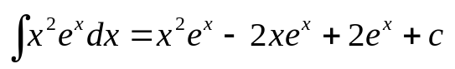
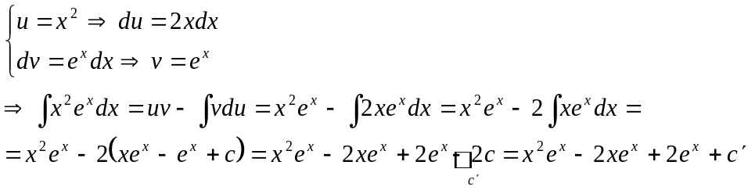

Type 3
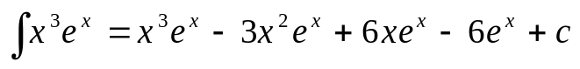
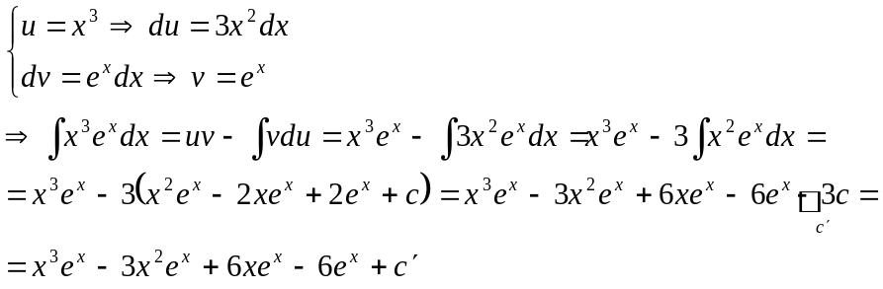

Type 4
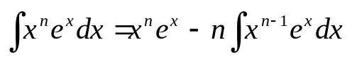
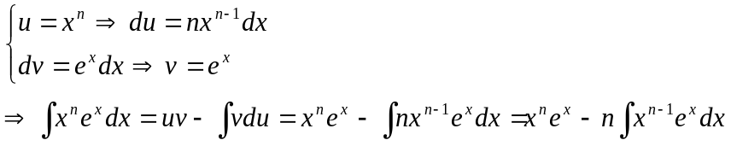

Examples
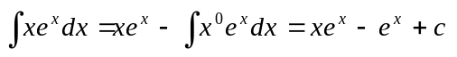

Type 5
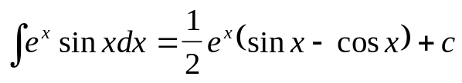
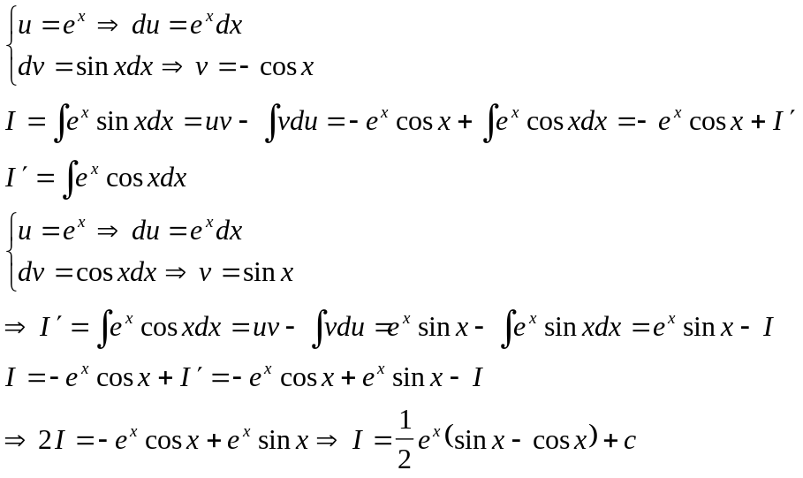

Type 6
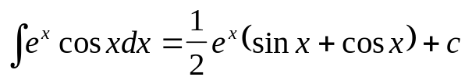
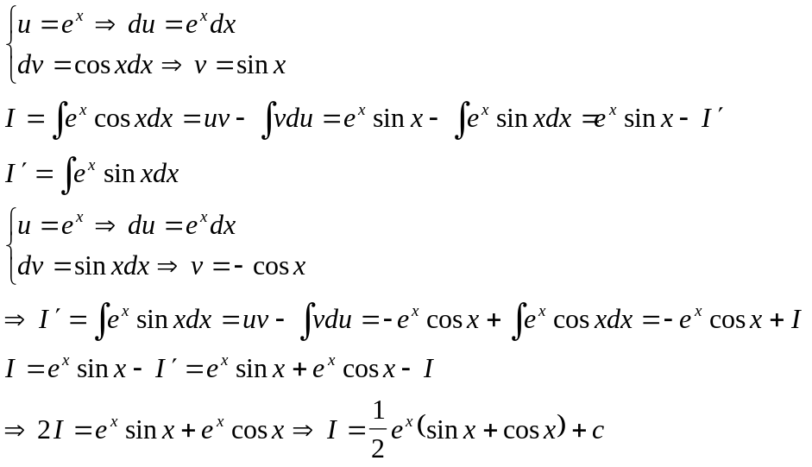

Type 7
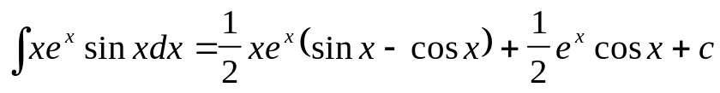
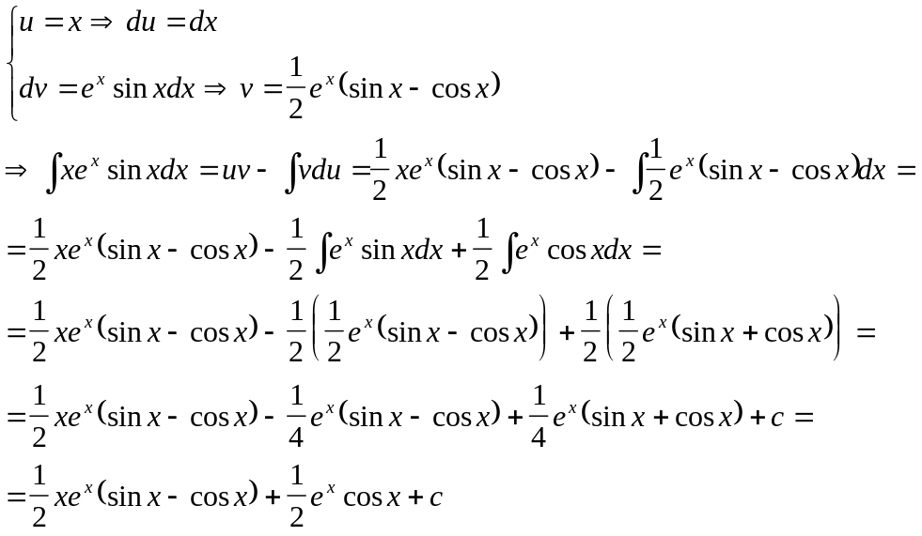

Type 8
